*Yuhao Chen*

*December 9th, 2019*

THE IMPACTS OF THE US-CHINA TRADEWAR ON US ELECTRICAL MANUFACTURING INDUSTRY

Table of Contents

Executive Summary 2

Introduction 3

Background 3

Thesis Statement 4

Industry Analysis: Electrical Manufacturing Industry 4

Industry Overview 4

Trade War Impact Analysis 5

Case Study: General Electric 7

Financial Downside 7

KPMG’s Solution 8

What GE does 10

Result 10

Recommendation 11

Government Advocation 11

Short-term Practices 11

Change of Suppliers 12

Conclusion 13

Reference 14

# Executive Summary

Since 2018 the United States of America and China have been in a trade confrontation, which has resulted in several rounds of tariff to each other. The tariffs have had a tremendous impact on National Electrical Manufacturer Association (NEMA) members. This report investigates the impact of US-China trade war on the electrical manufacturing industry. Based on analysis, this industry experienced stop of growth and decrease in profitability. To be more specific, the tariff increase both the direct costs of import and the indirect legislation/operational costs, which makes the industry less competitive and brings negative long-term effect.

The team, in order to determine a course of action for NEMA, constructed a case study on GE to see possible ways in which solution could be implemented. The report explains that, though GE faced standard problems of cost increase that all NEMA members faced, the company found several solutions to mitigate the effect of the tariffs. Together with its auditor and partner KPMG, GE proposes several approaches to mitigate the cost of the tariffs including applying for exclusion, change of product origin, applying first sale, negotiating suppliers, and strategic sourcing/change of suppliers.

Overall, the result shows that the tariffs placed by the US on Chinese goods not only hurt China, but also hurt its Electrical Manufacturing Industry. Thus, our recommendations for NEMA and NEMA members for reducing cost of tariffs are:

1. NEMA should place pressure on both the United States government and Chinese government to end the trade war, return to negotiation and sign a fair agreement. Footwear firms has already placed pressure on the government and made some progress.

2. Members of NEMA may consider applying short term tariffs reduction practices, including application for exclusion, change of origin. But those approaches may not be economically friendly to small firms.

3. Members of NEMA should consider relocate suppliers to the SEA region, especially Vietnam. However, those countries may not have enough working population and infrastructure so that cost may still be higher than pre-tariff Chinese imported goods.

# Introduction

## Background

Since United States has established diplomatic relations with China since 1979, two countries signed free trade agreement for improving national welfare. Although the free trade agreement enable citizens from both countries to improve living standard, the agreement also bring friction to the relationship of China and United States. After Trump became the president in 2016, the United States government began to take action to end this free trade relationship.

On March 22th, 2018, Trump announced tariffs US$60 billion worth of China goods because there was a huge trade deficit and China companies have been stealing business secrets and technology from United States companies (Bloomberg, 2019). As the China government fought back with tariffs, the trade war started and became severer. On September 17, 2018, the United States Trade Representative announces the finalized list of tariffs on US$200 billion worth of Chinese goods (Wong, 2019). Several days later, China announced additional tariffs on US$60 billion worth of US goods and cancellation of trade talk. Both countries agree to start negotiation and temporary pause new tariffs starting from December 2018 to March 2019 (Figure 1). Although the United States and China held multiples trade talks in April and May, both did not achieve an agreement. Thus, on May 10, 2019 US increased tariffs from 10 percent to 25 percent while China fought back with increasing tariffs on US$60 billion worth of US products.

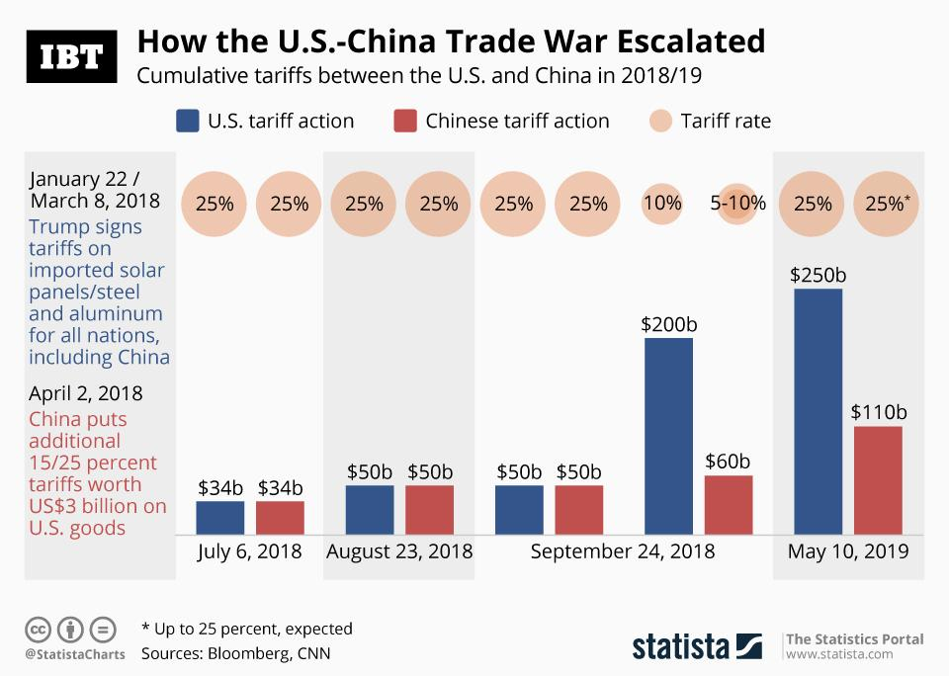

Figure 1: US and China has increased tariffs to each other since 2018

## Thesis Statement

The trade war has negative impacts on the Electrical Manufacturing Industry for several aspects. According to IPC’s report, an 86% majority of US electrical manufacturers are concerned about the increase in tariffs. The tariffs increase the cost of the companies because China is their major supplier. As a result, 69% of the companies report a decrease in profitability. This major decrease forces companies to reduce investment in the United States, hire fewer local workers, and moving manufacturing operations out of China. Those results of the tariffs increase the indirect cost of companies and create a negative cycle for US Electrical Manufacturing companies, members of National Electrical Manufacturers Association (NEMA).

National Electrical Manufacturers Association (NEMA) has been a strong supporter for a fair, rule-based, open free trade system for a long time. Although this industry concerns about the unfair trading practices from foreign competitors including government subsidies, intellectual property violations, and non-tariffs barriers to market entry, we believe that tariffs not a solution to the unfair trade practices.

Considering the disruptive impact of the tariffs imposed by the United States government, we present a 3 part solution with the 2020 election coming up. In the first step, NEMA and NEMA members should put pressure on both the United States government and the Chinese government to end the trade war, return to negotiation and sign a fair agreement. Then, NEMA members can apply short term strategies to mitigate cost. If the trade war continuous, members of NEMA should consider relocating suppliers to the SEA region, especially Vietnam.

# Industry Analysis: Electrical Manufacturing Industry

The National Electrical Manufacturers Association (NEMA) represents nearly 325 electrical equipment and medical imaging manufacturers that make safe, reliable, and efficient products and systems. In the section below, we will focus on the effect of trade war to electrical manufacture industry.

## Industry Overview

Electrical Manufacturing Industry (SIC 36xx: Electronic And Other Electrical Equipment And Components) includes establishments engaged in manufacturing machinery, apparatus, and supplies for the generation, storage, transmission, transformation, and utilization of electrical energy. Included are the manufacturing of electricity distribution equipment; electrical industrial apparatus; household appliances; electrical lighting and wiring equipment; radio and television receiving equipment; communications equipment; electronic components and accessories; and other electrical equipment and supplies (Occupational Safety and Health Administration, n.d.).

Over the five years to 2019, the Electrical Manufacturing Industry has declined due to rising import competition and adverse operating conditions (Figure 2). The substantial growth of US dollars makes import of foreign products more popular. Although economic conditions have since improved, industry revenue is expected to decline at an annualized rate of 1.2% to $41.2 billion. Improving downstream markets in more recent years have bolstered industry sales, while imports have continued to weigh down domestic operators. Import penetration has risen as a result of increased competition from countries with lower wages and fewer regulations, which enable them to manufacture industry products at lower costs. In response to external competitors, many US companies have established foreign manufacturing operations. Consequently, the number of domestic enterprises is expected to decline an annualized 0.6% during the current period. Amid cost-cutting measures such as consolidations, factory closures and offshoring, the average industry profit margin, measured as earnings before interest and taxes, is expected to decrease from 6.9% of revenue in 2014 to 5.1% in 2019 (IBISWorld, n.d.).

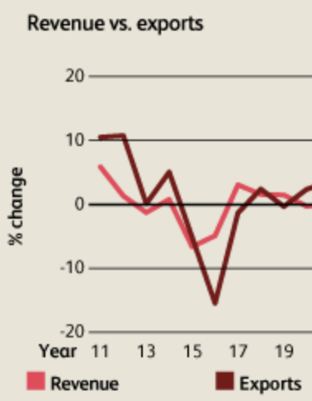

Figure 2: Electrical Manufacturing Industry’s revenue decreases as exports decrease

## Trade War Impact Analysis

Electrical Manufacturing Industry has faced a severe downturn in industry revenue since the trade war. IBISWorld estimates industry enterprises have declined an annualized 0.6% to 1,819 companies over the five years to 2019. Unpredictable change of input prices resulted in the industry gradually declining in profitability. The average industry profit margin, measured as earnings before interest and taxes, is estimated to decline to 5.1% in 2019 (IBISWorld, n.d.).

A majority of 69% companies reported lower margins as a result of the tariffs. The tighter margins came at a precarious time for the U.S. economy. Profit margins for U.S. nonfinancial corporations have been declining. After peaking at 15.7% of gross value added in 2015, profit margins have declined to 12% in the second quarter of 2019 (IPC, 2019).

According to IPC’s survey, the tariffs brought a heavy burden to companies in US Electrical Manufacturing Industry. The trade war had a negative impact on the profitability of companies in Electrical Manufacturing Industry in several ways: first, the tariffs increased the direct cost of imports. Electrical Manufacturing Industry has 36.6 billion dollars imports every year, while China captures about 16.9% of the import. Thus, US companies in this industry report the trade war tariffs increased on their cost of goods by about 31% (IPC, 2019). One quarter of companies in the Electrical Manufacturing Industry reported more than half of the dollar value of the products they import are facing higher tariffs. Besides, 55% of companies reported they are facing higher costs as a result of increased tariffs.

Moreover, companies Electrical Manufacturing Industry did not expect this dramatical increase in tariffs. Most electrical manufacturers, especially small ones, could not employ more effective mitigation strategies including a change of suppliers and application for exclusion. Thus, they had to let consumers pay for the extra cost. To mitigate the increase in cost, 65% of companies tried to increase the price (IPC, 2019). However, some companies have long-term contracts or other issues so that they cannot adjust prices. Besides, as prices of domestic electric equipment increased, US Electrical Manufacturing Industry faced more competition from the external market. As a result, thirty percent of companies reported their sales to go down as a result of the tariffs.

Furthermore, the high tariffs increased the indirect cost by bringing extra administrative and operational burdens to Electrical Manufacturing Industry. Companies now have to pay extra money for identifying which of their suppliers have added tariffs; identifying which components are now subject to tariffs and keeping track of changing rules; tracking and allocating tariffs costs; and ensuring that tariffs costs are captured in price quotes (IPC, 2019).

The decrease in profitability result of high tariffs is reducing companies’ ability to invest in

the United States. About one out of five US electrical manufacturers reported they have been reducing investment in the United States. In addition, the tariffs have negatively affected on the US investment market as a whole. Business fixed investment in the United States declined by 0.8% in the second quarter of 2019, which marks the biggest drop in over three years (IPC, 2019).

# Case Study: General Electric

General Electric co.(GE), one of the NEMA members, tries to mitigate huge loss brought by the trade war tariffs in some ways. We present a case study on how GE mitigates its tariffs cost.

## Financial Downside

GE is one of America’s largest exporters and employers, and a global leader in high-tech manufacturing. GE employs more than 100,000 workers in approximately 160 manufacturing facilities across the United States, supporting an additional 20,000 U.S. suppliers accounting for approximately 1,000,0000 jobs in this country. GE exports 60 percent of the products we make in the United States to its customers around the world (General Electric, 2018). However, GE experienced a decline in financial performance after US government post tariffs on imported Chinese goods.

GE’s stock price has been decreasing since 2018 as a result of the US-China trade war. It reached the lowest of 7.01 US dollars on December 7, 2018 (Mergentonline, 2019). Also, the company had experienced an increase in net loss from 0.72 million dollars and 2.62 million dollars.

GE executives did not anticipate that President Trump will hit China with such tariffs. Thus, the company did not realize the huge cost of it until the accounting record suggest the result. Rich Wrightington, executive director of sourcing at GE Appliances, said at the Institute for Supply Management (ISM) conference in Houston Monday that they could not believe Trump would immediately post such number of tariffs on China(Leonard, 2019). According to him, “ (Trump) He’s never going to do. It’s too big.” They specifically doubted Trump would decide to put steel tariffs on Canada and Mexico, two of the United States' closest trading partners.

The US government has released three lists of Section 301 tariffs, and all three affect GE (United States Trade Representative, 2019). List 1 affects more than 1,000 parts and more than 60 GE suppliers. List 2 affects more than 400 parts and more than 50 suppliers. But the biggest hit came from List 3, which covered more than 3,800 parts and more than 200 suppliers in GE's supply chain (Leonard, 2019).

GE's CEO estimated the tariffs could cost the company between $300 million and $400 million (Reuters, 2018). In May 2018, the company testified before the Office of the United States Trade Representative, suggesting the government for several exclusions to the tariffs (General Electric, 2018).

GE experienced huge losses brought by the tariffs, similar to other NEMA members. However, GE succeeds in finding ways to lower the costs associated with tariffs. The company made use of both long-term approaches and short them approaches to mitigate the cost of tariffs.

## KPMG’s Solution

KPMG LLP, GE’s auditor and partner, has proposed several ways to mitigate the cost of tariffs in their report (KPMG, 2019). The company believes that the uncertainty of this trade war is structural: although the US government believes that “the U.S. conflict with China reflects a growing economic rivalry between the two nations; a changing geopolitical landscape; and the intertwining of technology and trade.” Since the first round of US tariffs was levied, companies have been trying to find ways to mitigate the increased cost brought by the tariffs. According to KPMG, companies succeed in employing tariff mitigating strategy and have an average savings of 59 percent on tariffs. KPMG identified several effective practices to mitigate the tariffs:

1. Product exclusion requests

Many companies tried to apply for exclusion with the United States Trade Representative (USTR). According to the organization, “Exclusions are considered under certain circumstances, such as a lack of available, competitive products outside of China; tariffs causing economic harm to an industry; or the products being sourced not benefiting China’s 2025 industrial initiative.” However, companies must the prepare required documents and in-depth research to pass the exclusion application. KEMET Corporation (NYSE: KEM), a leading global supplier of electronic components, announced today that its request to have Tantalum Polymer capacitors excluded from Section 301 Chinese tariffs has been approved by the U.S. Trade Representative (KEMET, 2019).

1. Country of origin adjustments

The tariffs target imports with origin from China. Thus, companies can move portions of Chinese operations to another country to achieve a change in product origin. The key to achieve change of origin is to identify the most relevant components or processes of product origin. Then, companies may move these portions of operations outside China to achieve tariff avoidance. However, Customs and Border Patrol (CBP) has increased scrutiny on importers declaring abrupt changes to product origin (United States Customs and Border Protection, n.d.).

1. Strategic sourcing

By establishing a source of supply in more than one jurisdiction while ensuring visibility and agility, companies can be ready for quick sourcing changes in the event of new tariffs or other market barriers such as sanctions and quotas. A lot of technology companies, including Apple, Nintendo, Dell and HP, are moving their manufacturing operations out of China to avoid tariffs (Wright, 2019). Apple tries to avoid tariffs by moving 15% to 30% of their production capacity out of China. Japan’s Nintendo is also going to pull a portion of its video game console production out of China. Famous US personal laptop brand HP and Dell may move up to 30% of their notebook production out of China as well.

1. Value reduction/First sale tactics

The value of the transaction between manufacturer and middleman – which is usually less than the value of the second sale—is used as the basis for tariffs. Thus, US companies can use the first-sale principle to achieve cost savings (KPMG, 2019). This practice, which has been around a long time, is attractive to companies importing traditionally high-tariffed products such as apparel and footwear. However, many companies delayed taking this approach because the cost of preparing documents is high and managing this process take effort (Gtnexus, n.d.).

1. Foreign trade zones and bonded warehouses

For goods within a Foreign trade zones (FTZ), tariff payments are deferred until those goods are moved into the U.S. Tariffs can be avoided if certain goods are exported directly from an FTZ (KPMG, 2019). Also, when companies are applying tariff exclusion, goods can be stored duty free. US companies may avoid duties and maximize operational savings through integrating FTZ into their supply chain.

## What GE does

GE has long supported free and fair trade, with open access to markets both here and abroad. The company applies several strategies to mitigate the cost of tariffs.

First, GE placed pressure on the government to end the trade war (General Electric, 2018). According to Karan Bhatia, President of Government Affairs and Policy at GE, “We urge you to avoid any tariffs that would conflict with these goals”. In GE Testimony Regarding Proposed China Tariffs, Bhatia specifically pointed out that US government should exclude inputs that are intracompany transfers from facilities in China that are owned and controlled by U.S. manufacturers, exclude inputs that cannot be quickly replaced and exclude inputs containing high U.S. content.

Moreover, GE employed short term practices to reduce the tariffs. The company tried to reclassify some of its imports out of the list of tariffs. However, GE found some of their imports cannot be reclassified. GE also bought a large number of goods before the tariffs being executed.

As a company with a large market share, GE made use of its buying power to negotiate with the supplier and asked the supplier to help pay the tariff cost. GE’s executives met with about 30 different suppliers in China the week before Christmas to present them with this offer and succeeded in their approach. Some suppliers, however, were unwilling to pay for GE’s tariff because they provided exclusive products with no competition.

Worrying that the trade war may last longer, GE has been looking for new suppliers. According to GE, Eastern Europe and Southeast Asia are attractive. Besides, GE is reducing its reliance on outsourcing. This includes the assembly of items that it can do in its own factories. GE is also cooperating with KPMG for the first sale practice. GE’s engineering teams are also trying to rework the product design to find substitutions for cheap China imported components (Leonard, 2019). However, it takes GE time and effort to complete those practices.

## Result

GE’s executives believed the costs of tariffs to the company were about 20% lower now than when they were first put in place. However, GE has not found a complete solution for the cost of tariffs. According to Wrightington ,"There's certainly some cases where China is still the lowest cost, even when you add 25% and there's just not industry available ... [we just] have to pay more" (Leonard, 2019). In conclusion, although GE found several ways to mitigate the impact of tariffs, the company still faced the problem of increasing cost compared to the pre-trade war era.

# Recommendation

Based on the analysis above, there are three possible solutions for NEMA and NEMA members to reducing cost of tariffs: 1. NEMA should calls on the United States government and China government to end the trade war, return to negotiation and sign fair agreement; 2. Members of NEMA may consider applying short term tariffs reduction practices, including application for exclusion, change of origin; 3. Members of NEMA should consider relocate suppliers to the SEA region, especially Vietnam.

## Government Advocation

As President Trump set forth in his memorandum, the trade war is used to: maintain the United States’ position as a world leader in high-technology goods; strengthen the competitiveness of U.S. exports; and create American jobs (United Nations Conference on Trade and Development, 2019). Although the tariffs led to a 25% decrease in China’s export, Taiwan Province of China, Mexico, the European Union and Viet Nam among others are taking advantage of these losses. In fact, the tariffs hurt both Unite States and China economically. United States consumers have to pay higher prices while China’s exporters lose their business. In conclusion, it is unreasonable to continue this non-beneficial trade war which hurt both Unite States and China while benefiting other countries.

On May 20, 2019, 173 footwear firms, including global giants Nike and Adidas, wrote a letter to ask president Trump to stop increasing tax burden. Electrical manufacture firms to write a similar letter to the government (BBC, 2019). NEMA can call on the United States government and China government to end the trade war, return to negotiation and sign a fair agreement.

## Short-term Practices

In the short term, we recommend NEMA members to apply tariffs reduction tactics mentioned in the case study. Companies may request for exclusion of their products, change their import product origin and negotiate with suppliers. Besides, companies may collaborate with tax advising firms like Ernst & Young and KPMG to make use of more complicated methods including first sale and foreign trade zones. But small companies may find it hard to reduce cost because the legislation cost may exceed the costs of tariffs due to the small amount of production. No matter what, even if companies fail to apply the practices below, we suggest that increasing prices to let consumers pay for tariffs is not a reliable option.

## Change of Suppliers

NEMA members may consider choosing SEA region over the United States, Europe and China due to lower wages and geographical advantage if the trade war continues for a long period of time. Vietnam is currently the best option for new suppliers. The country has several advantages, Foreign and even China companies are moving to Vietnam in order to avoid tariffs and pay lower wages (Frost & Sullivan, 2019). Electronics giants, such as Intel and LG, have made huge investments in Vietnam in 2018. Samsung and Olympus also moved their factories in Shenzhen, Southern China to Vietnam. Those relocations enable Vietnam to grow to be a new manufacturing center. However, the capacity of working population in Vietnam (14.5 million) is much lower than that of China (200 million). As large companies move their manufacturers into Vietnam, it is likely that the working population restricts the country’s ability to production. Moreover, China has better infrastructure such as roads and ports, as well as cheaper intermediary cost. As a result, NEMA members may choose the SEA region, especially Vietnam, to be new suppliers but may also expect higher cost even in the long run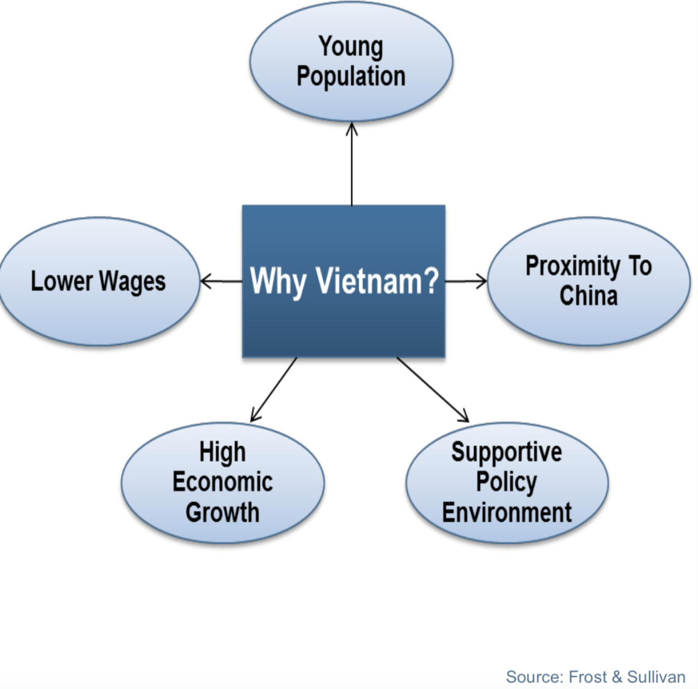

Figure 3: 5 advantages of choosing Vietnam as new supplier

# Conclusion

Since 2018, the United States of America and China have been in a trade confrontation, which has resulted in several rounds of tariffs to each other. The tariffs have a tremendous impact on NEMA members because the tariffs make the US Electrical Manufacturing industry experienced stop of growth and decrease in profitability. Besides, the tariffs increase manufacturers’ direct cost of import and indirect legislation/operational cost, making the industry less competitive compared to foreign industry.

To find a solution to such increased cost, the report presents an in-depth case study into one of the NEMA members, General Electric (GE). Although GE faced similar problems of cost increase, the company finds it ways several solutions to mitigate the effect of tariff. Together with its auditor and partner KPMG, GE proposes several approaches to mitigate the cost of tariff including applying for exclusion, change of product origin, applying first sale, negotiating suppliers, and strategic sourcing/change of suppliers.

Thus, we propose three recommendations for NEMA and NEMA members to reduce the cost of tariffs: 1. NEMA should place pressure the United States government and China government to end the trade war, return to negotiation and sign a fair agreement; 2. NEMA members may apply short term tariff reduction practices, including application for exclusion, change of origin; 3. NEMA members should consider relocating suppliers to the SEA region, especially Vietnam.

NEMA should take action to stop the trade war, and reduce the cost of tariffs immediately. Currently, the tariffs hurt manufacturers from both the United States and China, while benefiting their South Asia, European and North American competitors. Because the Electrical Manufacturing Industry is highly competitive, NEMA members are likely to lose market share if they do not take any action except for raising prices. Therefore, we highly recommend NEMA and NEMA members to follow the suggestions in order to mitigate the detrimental effect of the US tariffs imposed on goods imported from China.

# Reference

Amiti, M., Redding, S., & Weinstein, D. (2019). The impact of the 2018 trade war on US prices and welfare. doi: 10.3386/w25672

BBC News. (2019, May 22). US-China trade war: Shoe giants urge Trump to end tariffs. Retrieved from https://www.bbc.com/news/business-48360373.

Bloomberg. (2019, August 28). US-China trade war timeline: What’s happened since May 2019. Retrieved from https://www.bloomberg.com/news/articles/2019-08-28/u-s-china-trade-war-timeline-what-s-happened-since-may-2019.

Brown, C. P. (2019, September 20). US-China trade war: The guns of August. Retrieved from https://www.piie.com/blogs/trade-and-investment-policy-watch/us-china-trade-war-guns-august.

Casselman, B. (2019, May 30). Trade war starts changing manufacturers in hard-to-reverse ways. Retrieved from https://www.nytimes.com/2019/05/30/business/economy/trump-tariff-manufacturer.html.

Congressional Research Service (2019, June 23). U.S.-China Trade Issues. Retrieved from https://fas.org/sgp/crs/row/IF10030.pdf

Crowley, M. A. (2019). Trade war: the clash of economic systems endangering global prosperity. London: CEPR Press.

Egan, M. (2019, October 2). America's factories are getting crushed by Trump's trade war, not the Fed. Retrieved from https://www.cnn.com/2019/10/02/business/manufacturing-trade-war-trump-fed/index.html.

Frost & Sullivan. (2019, September 30). US-China Trade War—Global and Regional Impacts, Forecast to 2024. Retrieved from https://ww2.frost.com.

General Electric. (2018, May 16). GE testimony regarding proposed China tariffs. Retrieved from https://www.ge.com/reports/gevoices/ge-response-regarding-proposed-china-tariffs/.

General Electric. (2018, December 31). 2018 Annual Report. Retrieved from https://www.ge.com.

Gtnexus. (n.d.). Five Things to Know About First Sale. Retrieved from https://www.gtnexus.com.

IBISWorld. (n.d.) Electrical Equipment Manufacturing in the US. Retrieved from https://www.ibisworld.com.

IBISWorld. (n.d.) Medical Device Manufacturing in the US. Retrieved from https://www.ibisworld.com.

Ikenson, D. J. (2018, August 23). Which US industries will bear the brunt of Trump's China tariffs? Retrieved from: https://www.cato.org/blog/which-us-industries-will-bear-brunt-trumps-china-tariffs.

IPC. (2019, October 2). An IPC Research Report: U.S. Electronics Manufacturers Worried About Higher Tariffs and Laboring to Mitigate Impacts. Retrieved from http://www.ipc.org/

Jorgensen, B. (2019, July 30). 7 strategies for mitigating the impact of tariffs. Retrieved from https://epsnews.com/2019/07/30/7-strategies-for-mitigating-the-impact-of-tariffs/.

KEMET announces its tantalum capacitors no longer subject to Chinese tariffs: KEMET - Newsroom. (2019, July 15). Retrieved from http://newsroom.kemet.com/news-releases/news-release-details/kemet-announces-its-tantalum-capacitors-no-longer-subject.

KPMG LLP. (2019, February 22). Developing your Section 301 trade mitigation strategy. Retrieved from https://tax.kpmg.us/articles/2018/developing-your-section-301-trade-mitigation.html.

Lau, L. J. (2018). A better alternative to a trade war. SSRN Electronic Journal. doe: 10.2139/ssrn.3165838

Leonard, M. (2019, April 8). 8 strategies GE is using to mitigate tariff cost. Retrieved from https://www.supplychaindive.com/news/8-strategies-ge-mitigate-tariff-cost-ISM/552270/.

Mergent Online. (n.d.). General Electric Co. Retrieved from https://www.mergentonline.com.

Mutikani, L. (2019, September 3). U.S. manufacturing contracts as trade war with China bites. Retrieved from https://www.reuters.com/article/us-usa-economy/u-s-manufacturing-contracts-as-trade-war-with-china-bites-idUSKCN1VO1RH.

NEMA. (n.d.). The Association of Electrical Equipment and Medical Imaging Manufacturers. Retrieved from https://www.nema.org.

Occupational Safety and Health Administration. (n.d.). Law and Regulations. Retrieved from https://www.osha.gov.

Scott, A. (2018, July 20). GE CEO says China tariffs' 'gross cost' could be $400 million. Retrieved from https://www.reuters.com/article/us-ge-results-ceo/ge-ceo-says-china-tariffs-gross-cost-could-be-400-million-idUSKBN1KA1YH.

United Nations Conference on Trade and Development. (2019, November 9). Trade and Trade Diversion Effects of United States Tariffs on China. Retrieved from https://unctad.org.

Unite States Trade Representative. (2019, Oct 18). China Section 301-Tariff Actions and Exclusion Process. Retrieved from https://ustr.gov/issue-areas/enforcement/section-301-investigations/tariff-actions.

United States Customs and Border Protection. (n.d.). Marking of country of origin on US imports. Retrieved from https://www.cbp.gov/trade/rulings/informed-compliance-publications/marking-country-origin-us-imports.

Vivekananda International Foundation. (2018, September 17). US-CHINA Trade War: Analyses of Deeper Nuances and Wider Implications. Retrieved from https://www.vifindia.org.

Wong, Dorcas. (2019, November 28). The US-China trade war: A timeline. Retrieved from https://www.china-briefing.com/news/the-us-china-trade-war-a-timeline/.

Writer, S. (2019, July 17). China scrambles to stem manufacturing exodus as 50 companies leave. Retrieved from https://asia.nikkei.com/Economy/Trade-war/China-scrambles-to-stem-manufacturing-exodus-as-50-companies-leave.